**Course:**

**Database Management Systems (DBMS)**

**Assesment 3: Constraints**

**Done by: Prithak Gajurel**

**Registration Number: 20BCE2921**

**Task:**

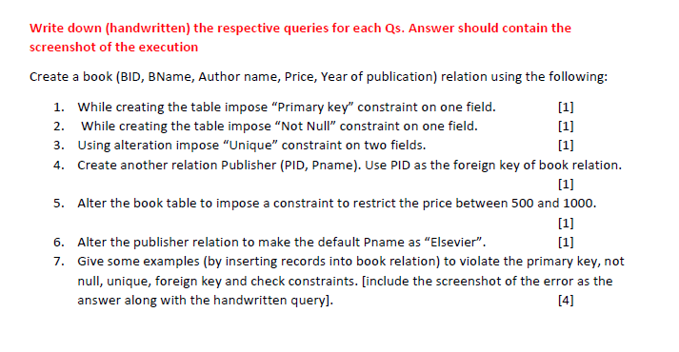**Initial metadata:**

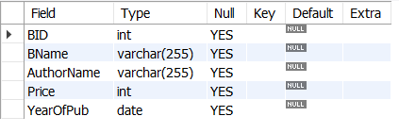

**Initial schema:**



**Code:**

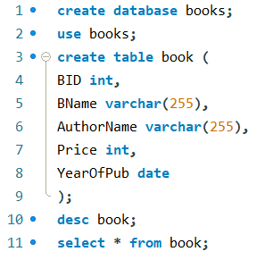

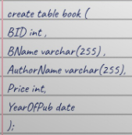



**Code:**

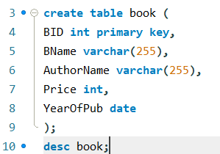

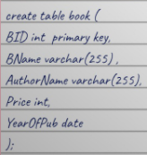

**Output:**

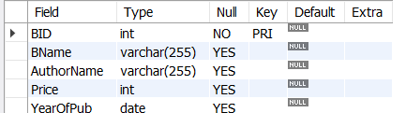



**Code:**

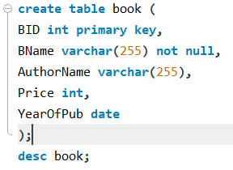

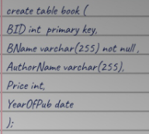

**Output:**

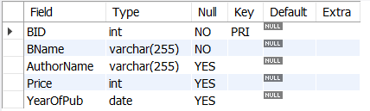



**Code:**

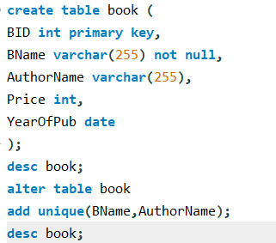

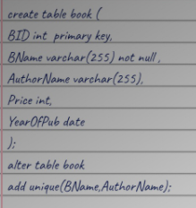

**Execution 1: Before implementing unique constraints:**

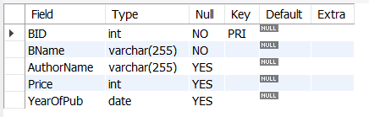

**Execution 2: After implementing unique constraints:**

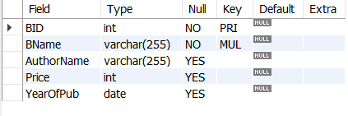



**Code:**

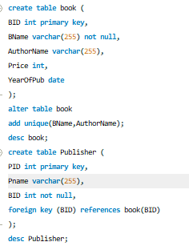

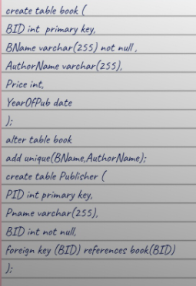

**Outputs:**

**Table book:**

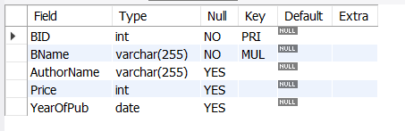

**Table Publisher:**

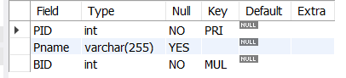



**Code:**



**Output:**

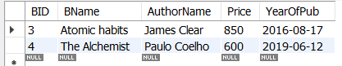

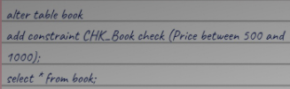



**Code:**





**Output:**

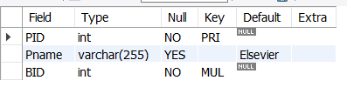

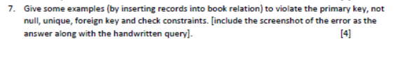

**# in order to violate the property of primary key:**

**Code:**

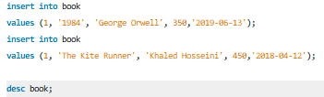

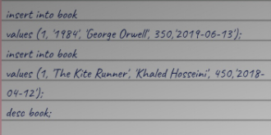

**Output / Error:**

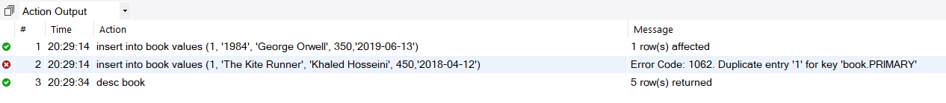

**Here the second error denotes the violation of property of primary key**

**Schema:**

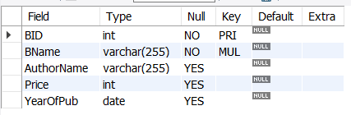

**# in order to violate the property of not null:**

**Code:**

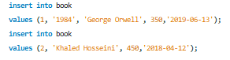

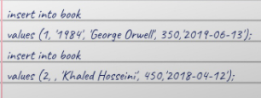

**Output / Error:**



**Here the second error denotes the violation of property of not null.**

**Schema:**



**# in order to violate the unique property:**

**Code:**

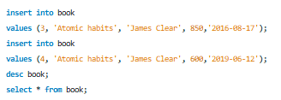

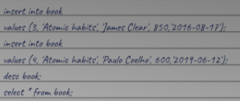

**Output / Error:**



**Here the second error denotes the violation of unique property.**

**Schema:**

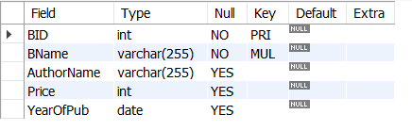

**Table:**

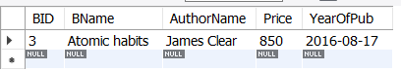

**# in order to violate the property of foreign key:**

**Code:**

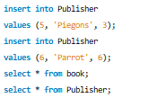

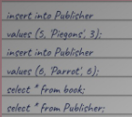

**Output / Error:**

**Main Table:**

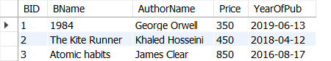

**Error:**



**Here the second error denotes the violation of foreign key property since there is no value ‘6’ in BID but we tried inserting in foreign table.**

**Hence,**

**Foreign table:**

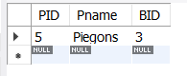

**# in order to violate the check constraint property:**

**Code:**

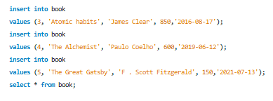

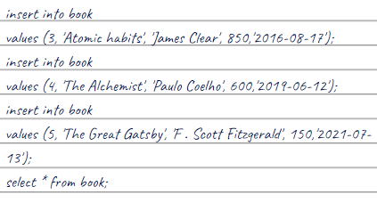

**Output / Error:**



**Here the third line error is caused due since we tried entering price as 150 but the check constraint is for the price in between 500 to 1000 which gets executed successfully.**

**Hence the table is as follows:**

